|  |  |  |  |  |  |
| --- | --- | --- | --- | --- | --- |
| |  | | --- | |  | |  | **PES University, Bengaluru** |  |  |
|  |  | (Established under Karnataka Act 16 of 2013) |  |  |
|  | **Department of Computer Science & Engineering** | | | |
|  |  | Session: **Aug - Nov 2016** |  |  |

**UE17CS204 – Web Technologies – I**

**Theory Assignment**

Report on

**TRAVEL INDIA**

**By:**

**Saipriya L. – PES1201701565**

**Bhargavi Priyasha Kumar– PES1201701802**

**Navneetha Rajan – PES1201700161**

**3rd Semester - Section A**

1. **Project Description**

A travel website that guides users on how to plan their trips across India. The user can sign up to the page as well as login to the page later because the user details are stored in a database on phpMyAdmin.

1. **Technologies Used**
   1. HTML
   2. CSS
   3. JavaScript
   4. PHP
   5. MySQL
2. **List of Functionalities**

Front End: Navigating through different pages across the website and making selections of destinations from the dropdown menu as well as location tags on the map page.

Back end: The user has the provision of signing up as well as logging into the website. His username and password are added to a database stored on phpMyAdmin. The user can plan his trip using the planner provided on the website.

1. **Link to Github repository**

https://github.com/bhargavikumar13/travel-india

1. **Screenshots of our project**

**Map page:**

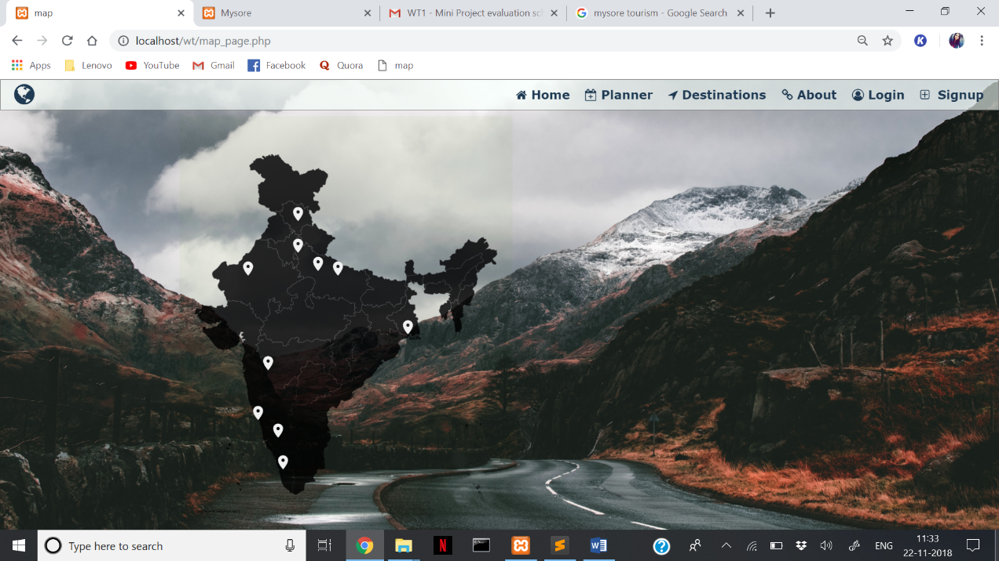

**Login Page:**

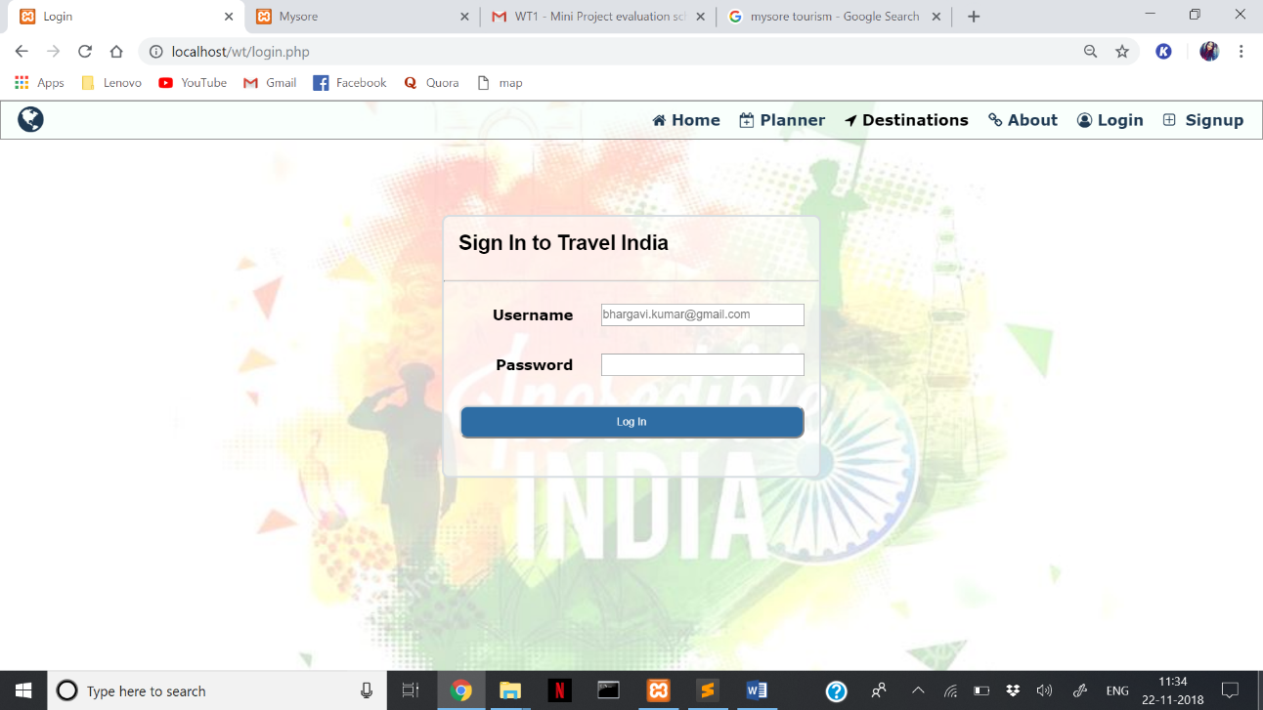

**Planner Page:**

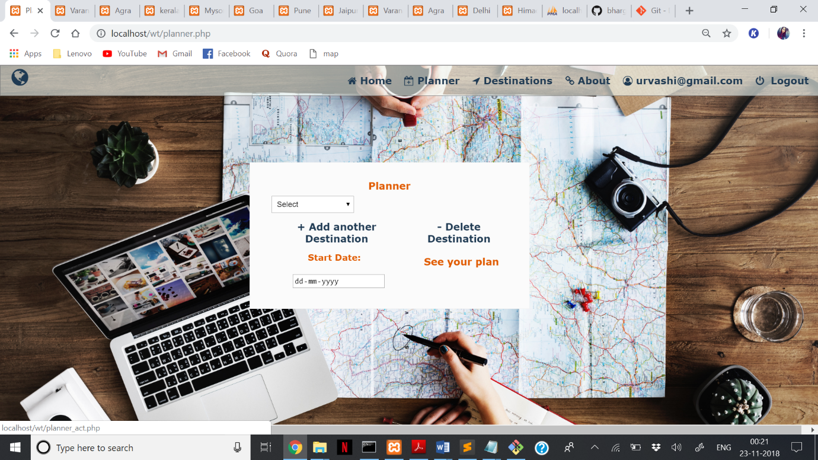

**Destination Page(Himachal Pradesh):**

